Curriculum Information – Year 4 – Spring 1
Class Saint  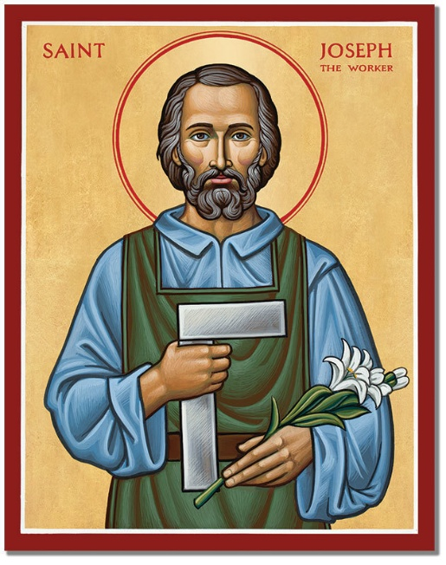 | St Joseph the Worker  Saint Joseph the Worker showed great faith, humility, and dedication in his life. He was the foster father of Jesus and cared for Mary and Jesus with love and responsibility. Joseph worked as a carpenter and taught Jesus the value of honest work. He trusted God completely, even when life was difficult, and protected his family from harm. His example reminds us that all work is important and should be done with care and respect.  Feast Day: 1st May  We will celebrate this special Feast Day in school during May to remember Joseph’s role as a protector and worker, and to thank God for the dignity of work and those who help us every day. |   CST Link: Participation  St Joseph took an active role in caring for Jesus and Mary and worked hard as a carpenter to provide for his family. His dedication reminds us that everyone has an important part to play in the Church and community by using their skills and talents to help others and serve God through honest work.
RE  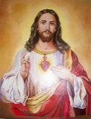 | Christmas  We will reflect on the announcements made by angels in the stories associated with the birth of John the Baptist and the birth of Jesus. We will understand how angels are heralds of important messages and will be able to consider ways in which Christians today are heralds of the message of Christ and how this can have a strong impact on the world today.  The Old Testament  In this area of learning, children will understand in more detail that God chose and called Moses and David for special tasks. We will recognise how God protected his people and that in the Psalms of David, we find images of God caring for and protecting His people. We will know that through the anointing with the Oil of Chrism in the Sacraments, Christians celebrate and respond to God’s call in their lives today. | 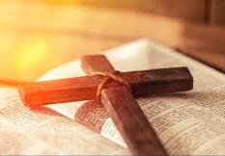
English   | 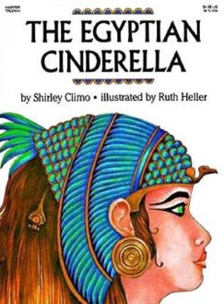  Book focus: We will use The Egyptian Cinderella by Shirley Climo as inspiration for our writing
Our outcome will be an explanation text about how Rhodopis became queen, using steps and reasons from the story. We will learn key grammar skills such as accurate punctuation, using conjunctions, expanding noun phrases, and applying Standard English verb forms. We will also practise using the present perfect tense and plan our ideas before writing. Editing will be part of every writing lesson to improve our work based on feedback. In Guided Reading, we will use a range of different texts to help increase our fluency and comprehension.

Ongoing throughout this and each term will be a strong focus on spelling, punctuation and handwriting. Please help your child to practise these skills at home. Spellings will be tested on a Thursday and new ones to practise will be sent home after the test ready for the following week. This is crucial to success in writing. Spelling scores are recorded in the spelling journals.

Maths   | Year 4  Multiplication and Division  This unit expands learning from Year 3, where children developed confidence in knowing when to multiply and an understanding of the difference between equal grouping and sharing. This unit also builds on what children learnt in Year 3 about remainders and on previous work in Year 4, where children learnt their multiplication facts up to 12 × 12. Continued practice at home is essential to success.  Perimeter  This unit builds on the concept of 2D shapes, in particular children’s understanding of the properties of squares and rectangles. It also applies children’s prior knowledge of measurement in practical contexts.
  Science | Electricity  Children will:  - Identify common appliances that run on electricity.  - Construct a simple series electrical circuit, identifying and naming its basic parts, including cells, wires, bulbs, switches and buzzers.  - Identify whether or not a lamp will light in a simple series circuit, based on whether or not the lamp is part of a complete loop with a battery.  - Recognise that a switch opens and closes a circuit and associate this with whether or not a lamp lights in a simple series circuit.  - Recognise some common conductors and insulators, and associate metals with being good conductors.  Working scientifically  - Identify and group common appliances that run on electricity (Identifying, classifying and grouping)  - Ask questions and construct simple series circuits, naming parts like cells, wires, bulbs, switches and buzzers (Comparative and fair testing)  - Gather and record data to check if a lamp lights when the circuit is complete (Observing and recording)  - Test and sort materials into conductors and insulators, looking for patterns such as metals being good conductors (Pattern seeking & classifying)  - Investigate how a switch opens and closes a circuit and how this affects whether a lamp lights (Comparative and fair testing & observing over time)
 | 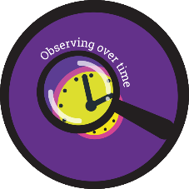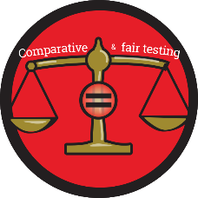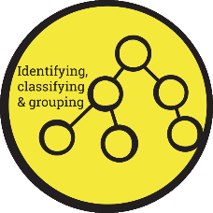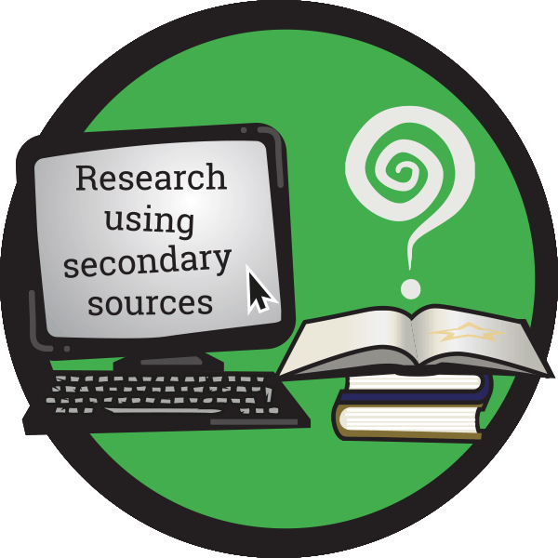
History  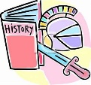 | Our History Learning – Ancient Egypt  We will learn what an ancient civilisation is and where Ancient Egypt fits on a timeline. We will explore artefacts and sources to find out about daily life, writing, and beliefs.  We will learn about the Pharaohs and hierarchy, Egyptian gods and goddesses, and their belief in the afterlife, including mummification. Finally, we will discover why Tutankhamun is so famous and what his tomb tells us about Ancient Egypt.  By the end, we will know the key features of Ancient Egypt and other advanced societies from around 3000 years ago. |   CST Link - Dignity of the Human Person  Studying Ancient Egypt helps us appreciate the creativity, achievements, and beliefs of people from the past. It reminds us that every person, in every time and culture, has value and deserves respect. Just as the Egyptians built complex societies and expressed their faith through art, writing, and architecture, we are called to recognise the dignity of all people today.
  Art | Our Art Learning – Still Life  We will explore the still life genre, starting with traditional still life paintings and then comparing them to contemporary examples. We will use our sketchbooks to record ideas, make visual notes, and reflect on the meanings of objects in art.  We will learn how to draw from observation and experiment with line, colour, shape, texture, form, and composition to make our artwork interesting. Then, we will create our own still life piece using these skills.  Finally, we will share and reflect on our work, explaining how our sketchbook helped us develop our ideas and techniques.
Computing   | Hardware  Children will learn the different parts of a desktop computer and will know what the function of each part is.  Writing for different audiences  In this unit, children will practice using different formats to present information, suitable for its audience and purpose. Children will use simulated scenarios to write news reports and campaigns. | 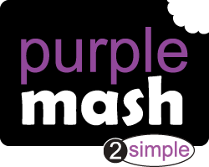
PE   | PE Day: Monday  PE Day: Please have full PE Kit in school on this day. | 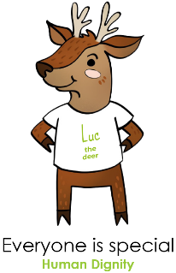  CST Link: Human Dignity Every person is made in God’s image and should be respected through looking after our health and wellbeing
  Music | Music will be taught by Mrs Wallace each week. The children will have different musical opportunities to help them to understand rhythm and pulse. | 
PSHE   | Being me in my world  This half term, we will explore our hopes and wishes for this coming year and think about ways to combat challenges that we might face.  We will think about our responsibilities and how we can become more independent in our learning. | CST Link: Participation Pupils will learn that they have a role in shaping their own lives and understanding goals encourages active participation to use our God-given talents well.
Key events for the half term | Tuesday 3rd February and Wednesday 4th February – Parent  Consultations  Sunday 8th February – Family Mass (Mass of Commitment for children  receiving the Sacraments of Reconciliation and First Holy Communion)  Other key dates will continue to be shared throughout the term.
Homework | - Two pieces of homework will be handed out on a Thursday and should be completed and handed in on the Tuesday that follows.  - Spellings are tested on a Thursday (New spellings will be given out on a Thursday following the test).  - Morning Fluency sheets will continue to be handed out with a short daily Maths task to complete.  - Reading at home should take place five times a week. This will be monitored through daily diary checks. Children will receive a reading book and will also bring home their choice of book from our school library.

