Curriculum Information – Year 5 – Spring 1
Class Saint  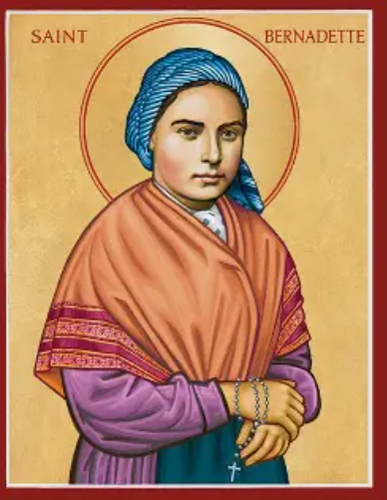 | Feast Day: 16th April  (Class Saint assembly for Year 5 will also be on this day)  St Bernadette represents humility, deep faith, and hope. People did not believe her visions of the Virgin Mary, often saying she was “only a messenger,” which shows her strong humility. Her life is also seen as a symbol of courage and devotion, because she stayed true to what she had seen despite illness, doubt, and questioning from others. Many people also see her as a sign of healing and comfort, as the spring at Lourdes — revealed during her visions — became a place linked with spiritual and physical healing for millions. |   CST Link: Solidarity  When Mary appeared to Bernadette, she trusted Bernadette with an important message. God invites ordinary people to be involved, not just leaders or experts.
RE  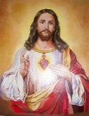 | Christmas  We will reflect on the announcements made by angels in the stories associated with the birth of John the Baptist and the birth of Jesus. We will understand how angels are heralds of important messages and will be able to consider ways in which Christians today are heralds of the message of Christ and how this can have a strong impact on the world today.  Parables and The Sayings of Jesus  In this unit, children gain a greater knowledge and understanding of the Parables of Jesus. They explore the concept of the Kingdom of God from the teachings of Jesus and ways in which Christians respond to this teaching today through their belonging to the Church. | 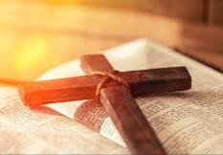
English   | 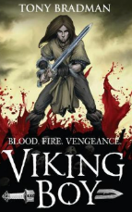  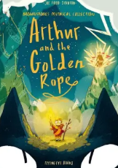  Book focus: The Viking Boy by Tony Bradman and Arthur and the Golden Rope by Joe Todd-Stanton
We will use our class book as inspiration for our own writing. We will learn key language and grammar skills to help us write a narrative action scene from part of the book, how to make a newspaper report and from our other text, we will learn how to write instructions. In Guided Reading, we will use a range of different texts to help increase our fluency and comprehension.

Ongoing throughout this and each term will be a strong focus on spelling, punctuation and handwriting. Please help your child to practise these skills at home. Spellings will be tested on a Thursday and new ones to practise will be sent home after the test ready for the following week. This is crucial to success in writing. Spelling scores will continue to be recorded by the children in their reading diaries so that incorrect ones can be revisited at home.

Maths   | Year 5  In this unit, children extend their understanding of multiplication and division using a range of methods to calculate with up to 4-digit numbers, multiplying by 2-digit numbers or dividing by 1-digit numbers while dealing with exchange. Children continue to develop reasoning and problem-solving skills while interpreting remainders.  This unit is important because it further develops children’s understanding of multiplication and division and interpreting remainders, drawing on a variety of written methods and applying knowledge of multiples. It encourages problem-solving while also exploring efficient methods.  Multiplication and Division 2, Fractions 3, Decimals and Percentages, Measures – Perimeter and Area, Graphs and tables
  Science | Forces and Magnets  Children will:  - describe the movement of the Earth and other planets relative to the sun in the solar system  - describe the movement of the moon relative to the Earth  - describe the sun, Earth and moon as approximately spherical bodies  - use the idea of the Earth’s rotation to explain day and night and the apparent movement of the sun across the sky  Working scientifically  Ways of where we will work scientifically is by: comparing the time of day at different places on the Earth through internet links and direct communication; creating simple models of the solar system; constructing simple shadow clocks and sundials, calibrated to show midday and the start and end of the school day; finding out why some people think that structures such as Stonehenge might have been used as astronomical clocks.
 | 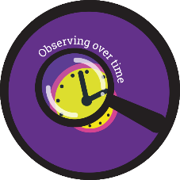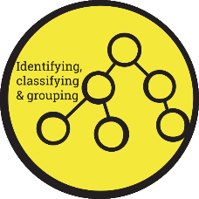
History   | The Vikings  Children will explore:  - Know where the Vikings originated from and show this on a map.  - Know that the Anglo-Saxons and Vikings were often in conflict.  - Know why the Vikings frequently won battles with the Anglo-Saxons. | 
  Art | Year 5 will be discovering and making monotypes.  Children will learn:  - To identify monotype prints made by artists  - To open my mark-making vocabulary by varying the tool, hold, pressure, speed and intention  - To respond to a poem in the form of a zine made from painted, collaged and printed elements  - To display the work made through the half term and reflect on the outcomes
Computing   | • To use formulae within a spreadsheet to convert measurements of length and distance.  • To use a spreadsheet to model a real-life problem.  • To use spreadsheet tools to investigate probability.  • To use the count tool to answer hypotheses about common letters in use. | 
PE   | PE Day: Friday  This half term, Year 5 have a fantastic opportunity to work with Angela Beardmore School of Dance during their PE lessons. They will focus on specific dance words, understand basic choreography and develop more complex routines involving unison, canon and learn to lead a group without adult support. | 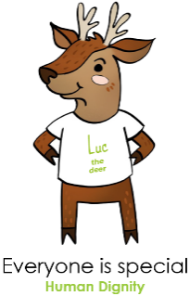  CST Link: Human Dignity  Every person is made in God’s image and should be respected through looking after our health and well-being
  Music | Music will be taught by Mrs Wallace each week. The children will be exploring Motown, which is a blended rhythm of the blues and pop elements. They will be exploring tone, pitch and timbre. | 
PSHE   | Being me in my world  This half term, we will explore dreams and goals. Children will look at different jobs while thinking about what job they might want in the future. As they progress, they will also look at other dreams and goals that you might have in your life and how they can support people/each other in the community. | 
Key events for the half term | - Bikeability week commencing 5th January 2026  - Space school trip with Year 5/6 on the 19thJanuary 2026  - Parents evening: 3rd February 3:30-6:30 & 4th February 3:30-7 pm
Homework | - Two pieces of homework will be handed out on a Thursday (one Maths and one English) and should be completed and handed in on the Tuesday that follows.  - Spellings are tested on a Thursday (New spellings will be given out on a Thursday following the test).  - Morning Fluency sheets will continue to be handed out with a short daily Maths task to complete. There will no longer be Friday on the sheet. Instead, children on Friday morning will complete any fix it work that they have accumulated over the week in their school books.  - Reading at home should take place five times a week. This will be monitored through daily diary checks. Children will receive a reading book and will also bring home their choice of book from our school library.

