Curriculum Information – Year 3 – Autumn 1
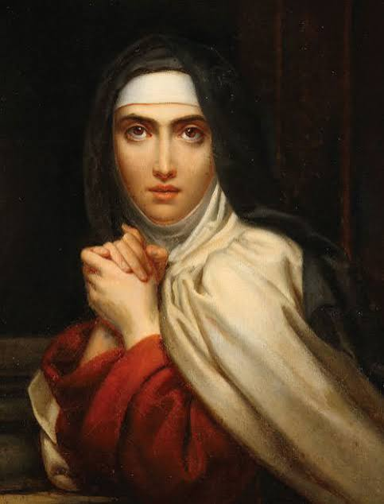  Class Saint | St Teresa of Avila  Saint Teresa of Avila was a Spanish saint who lived during the 1500s. From a young age, Teresa had a strong love for God and wanted to dedicate her life to Him. She believed that prayer was a way of becoming closer to God and spent much of her life encouraging others to develop their own relationship with Him. She is the patron saint of headache sufferers and Catholic writers.  St Teresa teaches us the importance of taking time to pray, thinking carefully about our choices and trusting God when life becomes challenging. We can follow St Teresa’s example by supporting our friends and putting our faith into practice every day.  Feast Day: 15th October  We will celebrate this special Feast Day in school where we will explore her life. | 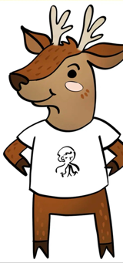  CST Link: Human Dignity  Teresa believed that every person has a unique relationship with God and that our lives have meaning and purpose. This encourages us to recognise the worth of everyone around us, regardless of their differences.
RE  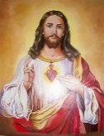 | Creation and Covenant  The pupils will read two creation accounts from the Bible and learn that they are theological and poetic accounts. They will understand that all people are created in the image and likeness of God, giving every person dignity and worth. They will make links between scripture, Catholic Social Teaching, fairness, equality, and caring for others. Pupils will also develop their understanding of stewardship, seeing it not just as keeping things tidy, but as a responsibility to care for people and the world God has made. | 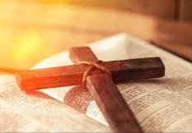
English   | For the first four weeks of term, we will be consolidating key punctuation and grammar skills including nouns, verbs and building single clause sentences  Book Focus: Stone Age Boy | 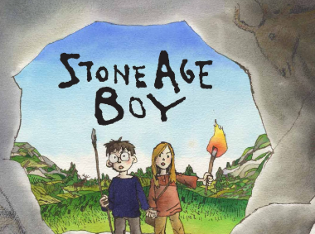
We will use our class book as inspiration for our own writing. We will learn key language and grammar skills, such as subordinating and coordinating conjunctions and expanded noun phrases, to help us to write a non-chronological report.

In Guided Reading, we will use a range of different texts to help increase our fluency and comprehension.
Maths   | Place Value  This half term, the children will be learning to:  - count in 100s  - Partition a number in 100s, 10s and 1s  - Find 100, 10 and 1 more or less  - Compare and order numbers up to 100  - Count in 50s
  Science | Rocks and Soils  Pupils will:  - Compare and group together different kinds of rocks on the basis of their appearance and simple physical properties.  - Recognise that soils are made from rocks and organic matter.  - Describe in simple terms how fossils are formed when things that have lived are trapped within rock.  Working scientifically  - Compare and group different types of rocks on the basis of their appearance  - Ask questions and carry out tests on how permeable different types of soils are  - Gather and record data to answer questions  - Identify evidence of weathering and erosion through observations
 | 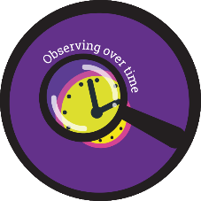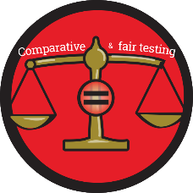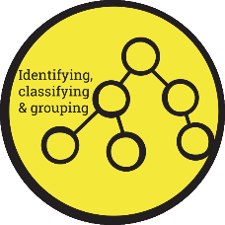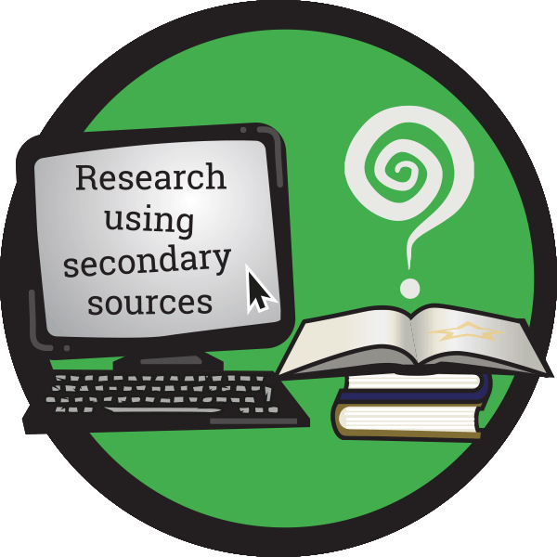
History  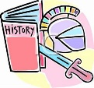 | Stone Age to the Iron Age  This half term, the children will exploring Britain from the Stone Age to the Iron Age. They will explore how people lived, ate and hunted, and how this changed over time. | 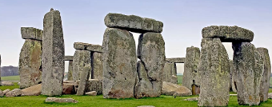
Art   | Gestural Drawing  Pupils will learn to:  - Record their observations and use them to review and revisit ideas  - Improve their mastery of art and design techniques, including drawing, painting and sculpture with a range of materials (for example, pencil, charcoal, paint, clay)  - To know about great artists, architects and designers in history. | 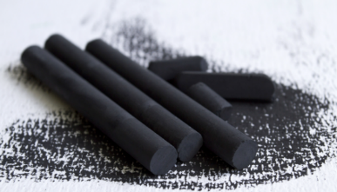
Computing   | Online Safety  The children will be able to describe appropriate ways to behave towards other people online and why this is important.  Email  The children will learn how to respond to, compose and add attachments to emails as well as consider the safety aspects of email communication. | 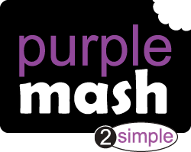
PE   | PE Day: Wednesday  This half term, Year 3 will be receiving dance lessons from Angela Beardmore Dance Company. This will take place on Wednesday afternoons. Children will be required to come to school in their PE kits which they will wear for the whole day. | 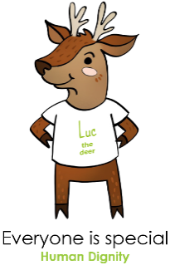
  Music | Music will be taught by Mrs Wallace each week. The focus for this half term will be Native American Music. | 
PSHE   | Being Me  This half term, the children will be working on recognising their worth and identifying positive things about themselves and their achievements. They will also be practicing to set personal goals. | 
French | French Greetings with Puppets  The children will  - Greet someone and introduce themselves in French  - Use the correct French greeting for the time of day  - Ask and answer a question about feelings  - Perform a finger rhyme | 
Homework | - Two pieces of homework will be handed out on a Thursday and should be completed and handed in on the Tuesday that follows.  - Morning Fluency sheets will continue to be handed out with a short daily Maths task to complete.  - Reading at home should take place five times a week. This will be monitored through daily diary checks. Children will receive a reading book and will also bring home their choice of book from our school library.

