These are the calculation methods used in Year 2.
Addition
Use a number line
17 + 25
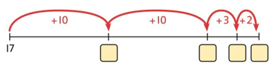
Add the 10s and then recombine.
- 20 = ? 30 + 20 = 50 50 + 7 = 57 37 + 20 = 57

Use related facts to help them e.g. 4 + 3 = 7 4 tens + 3 tens = 7 tens so 40 + 30 = 70

Subtraction
Use a number line
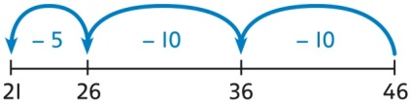

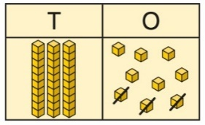
Children can draw base ten to help them complete calculations.
39 -3 = 36

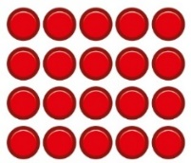
Multiplication
Repeated addition on a number line Use an array
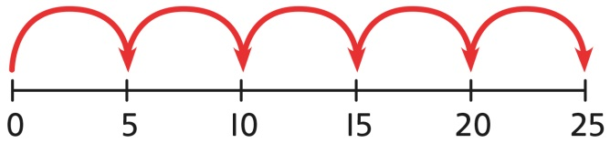
5 X 5 = 25 5 groups of 5 5 x 5 = 25

Division
Repeated subtraction on a number line Bar model to share
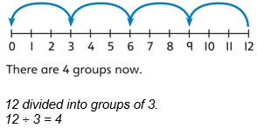
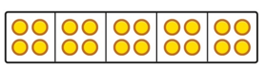
20 shared into 5 equal parts.
There are 4 in each part.

