These are the written calculation methods used in Year 5.
Addition
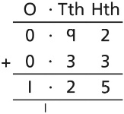
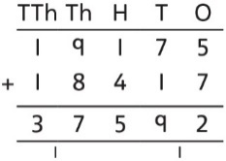
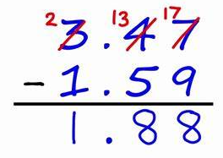
Subtraction
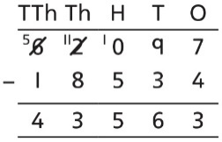
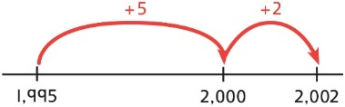
To subtract two large numbers that are close, children find the difference by counting on.
2,002 − 1,995 = ?

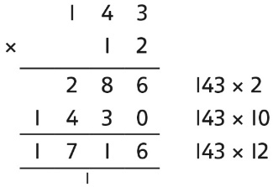
Multiplication
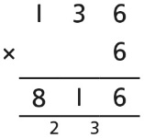

Division
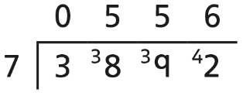
In addition to the above written methods, Y5 will use partitioning to help them calculate mentally/use jottings. For example:
15 x 6 10 x 6= 60 5 x 6 = 30 60 + 30 = 90
65 + 47 60 + 40 = 100 5 + 7 = 12 100 + 12 = 112
They can also use related facts such as: 4 x 5 = 20 so 40 x 50 = 2000

