These are the written calculation methods used in Year 6.
Addition

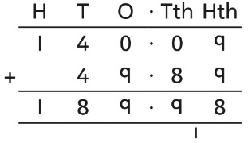
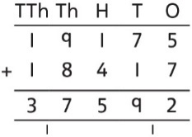

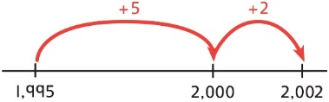
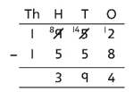
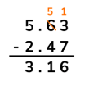
Subtraction
To subtract two large numbers that are close, children find the difference by counting on.

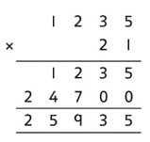
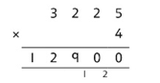
Multiplication

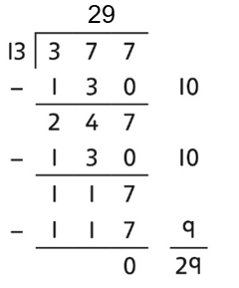
Division
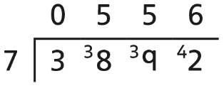

- In addition to the above written methods, Y6 will use partitioning to help them calculate mentally/use jottings. For example:
15 x 6 10 x 6= 60 5 x 6 = 30 60 + 30 = 90
65 + 47 60 + 40 = 100 5 + 7 = 12 100 + 12 = 112

- Use related facts such as: 4 x 5 = 20 so 40 x 50 = 200

- Use adjusting e.g. 98 + 46 100 + 46 = 146 146 -2 = 144 so 98 + 46 = 144

- Use factors to divide e.g. 1260 ÷ 14 =?
1,260 ÷ 2 = 630 630 ÷ 7 = 90 so 1,260 ÷ 14 = 90

