Wednesday 24th September2025

Harvest Celebration Mass – Thursday 2nd October

Dear Parent/ Carer,

This year, we’ll be celebrating the Harvest Festival at Sacred Heart Catholic Church during our Whole School Mass (YR-6) on Thursday 2nd October.

As always, we are grateful to our volunteers who are able to join us and walk across to church with our children. If you are able to support, please arrive at school by 9.10am.

As part of our commitment to serving others, we will be making food donations to our local Foodbank this year and our Catholic Life Leaders will be working hard to collect food items over the next week.

If you are able to support with food donations this year and would like to contribute to our Harvest collection, please send in any tinned food, jars of sauce, pasta, rice or cereal into school by Wednesday 1st October.

Mass will begin on Thursday 2nd October at 9.30am. We hope to see you there and hope that we can work together to help those in most need in our local area.

Thank you for your continued generosity and support.

Yours Sincerely
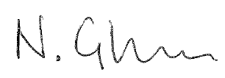
Mr N Glover
Principal

